**Employment Trends for the Environmental Science and Natural Resource Pathway**

Introduction

It is important to note several trends and special circumstances that underlie this rapidly evolving field of study. The Environmental Sciences (soil science, plant science, animal science, environmental science, geographic information science) prepare students for a very wide range of careers. Many of these careers particularly those in government agencies require a bachelor’s degree for significant advancement*. The nature of the agriculture and natural resources industry in California and the location of Victor Valley College allow students to access jobs in several contiguous counties – Los Angeles, Riverside and Kern Counties. These are particularly important because San Bernardino County provides much of the natural resources to the population centers in these counties and Kern County is one of the most important agricultural counties in the United States.

*This ESNR pathway with the AST degree option provides one of very few mechanisms for an estimated 40% of High School Graduates to seamlessly transfer to these majors in the Cal State System given that only less than 10% of HS seniors are transfer directly to a University.



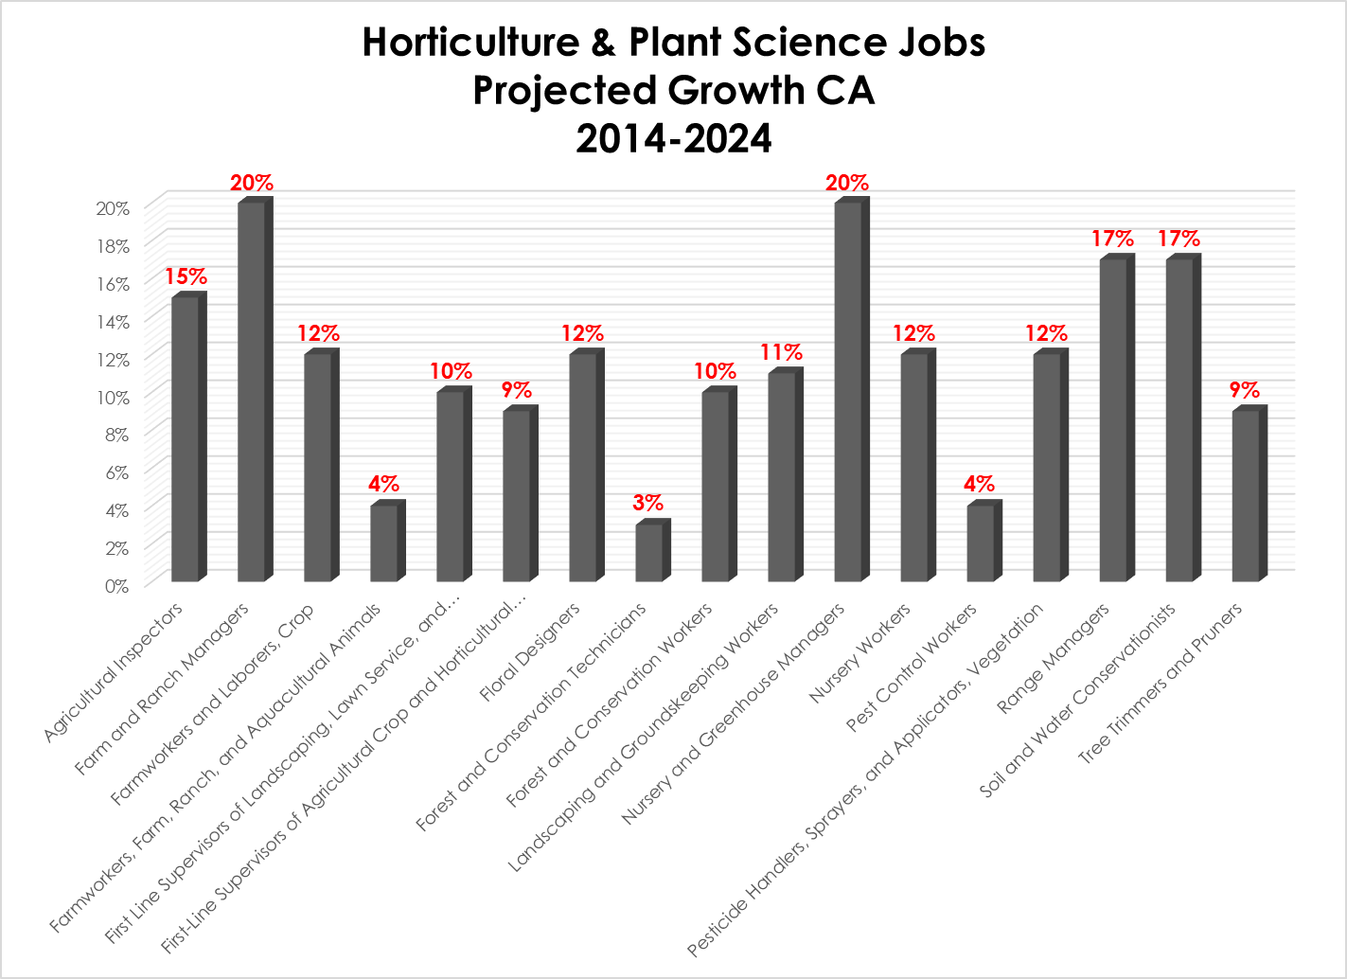 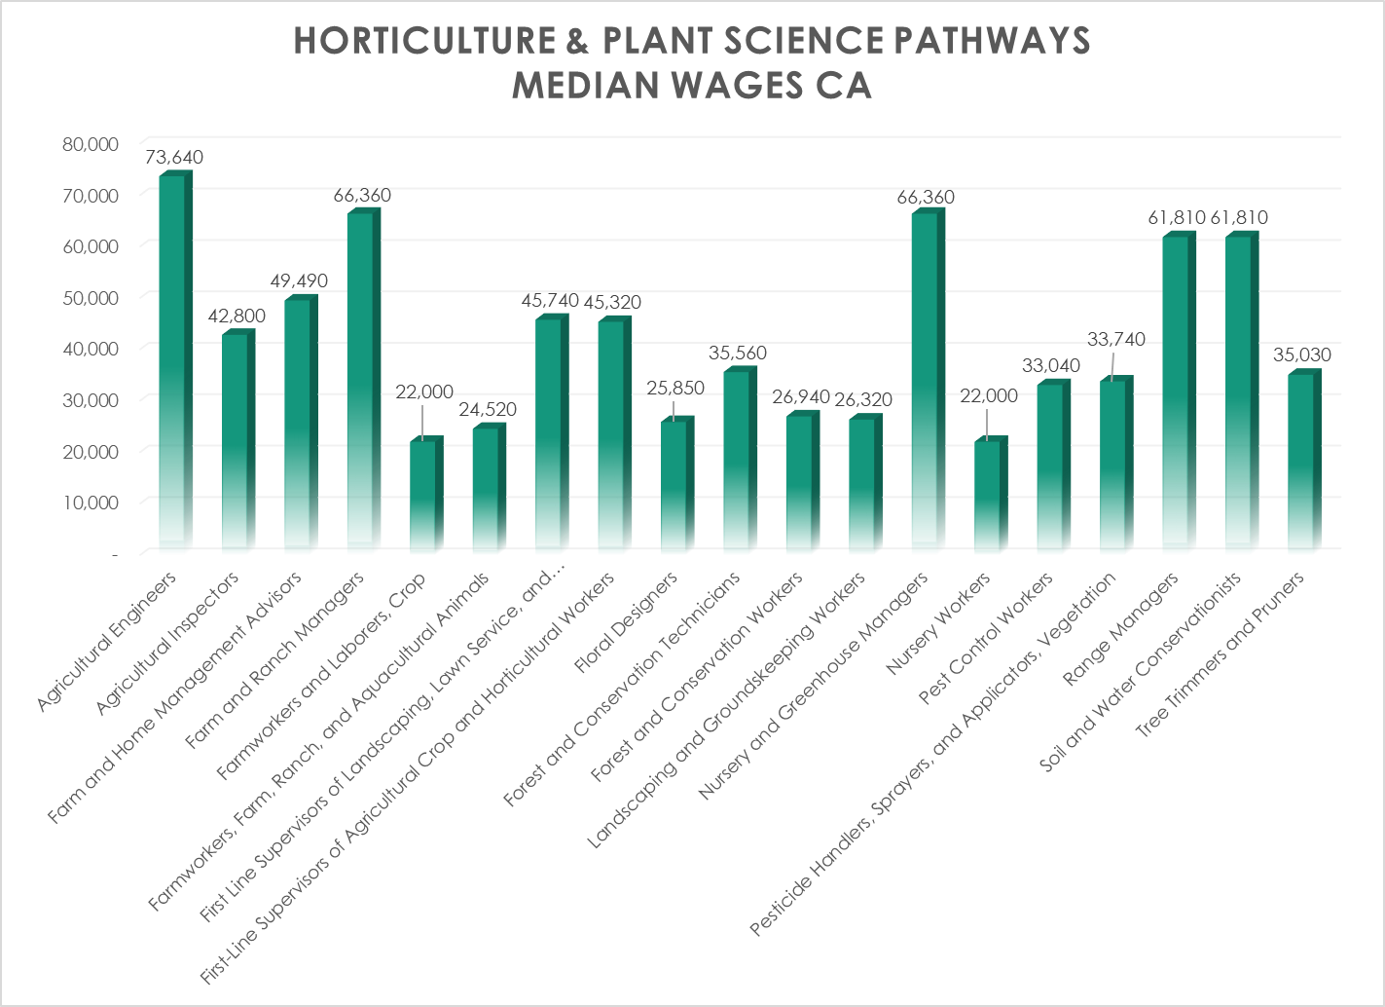

**Nursery and Greenhouse Managers - 11-9013.01**

**Projected Employment for Farmers, Ranchers, and Other Agricultural Managers, including Nursery and Greenhouse Managers in CALIFORNIA**

|  |  |
| --- | --- |
| **Median wages (2016)** | $31.91 hourly, $66,360 annual |
|  | |
| **Employment (2016)** | 1,029,000 employees |
| **Projected growth (2016-2026)** | Average (5% to 9%) Average (5% to 9%)  California/Riverside/San Bernardino +20% Job Growth |
| **Projected job openings (2016-2026)** | 84,800 |
|  | |
| **Top industries (2016)** | [Agriculture, Forestry, Fishing, and Hunting](https://www.onetonline.org/find/industry?j=11-9013.01&i=11) (27% employed in this sector)  [(see all industries)](https://www.onetonline.org/link/industry/11-9013.01) |

**Farm and Ranch Managers - 11-9013.02**

**Projected Employment for Farmers, Ranchers, and Other Agricultural Managers, including Farm and Ranch Managers in CALIFORNIA**

|  |  |
| --- | --- |
| **Median wages (2016)** | $31.91 hourly, $66,360 annual |
|  | |
| **Employment (2016)** | 1,029,000 employees |
| **Projected growth (2016-2026)** | Average (5% to 9%) Average (5% to 9%)  California/Riverside/San Bernardino +20% Growth |
| **Projected job openings (2016-2026)** | 84,800 |
|  | |
| **Top industries (2016)** | [Agriculture, Forestry, Fishing, and Hunting](https://www.onetonline.org/find/industry?j=11-9013.02&i=11) (27% employed in this sector)  [(see all industries)](https://www.onetonline.org/link/industry/11-9013.02) |

**Soil and Water Conservationists - 19-1031.01**

**Projected Employment for Conservation Scientists, including Soil and Water Conservationists in CALIFORNIA**

|  |  |
| --- | --- |
| **Median wages (2016)** | $29.72 hourly, $61,810 annual |
|  | |
| **Employment (2016)** | 22,000 employees |
| **Projected growth (2016-2026)** | Average (5% to 9%) Average (5% to 9%)  California/Riverside/San Bernardino +17% Growth |
| **Projected job openings (2016-2026)** | 2,000 |
|  | |
| **Top industries (2016)** | [Government](https://www.onetonline.org/find/industry?j=19-1031.01&i=93) (75% employed in this sector)  [Other Services (Except Public Administration)](https://www.onetonline.org/find/industry?j=19-1031.01&i=81) (12%)  [(see all industries)](https://www.onetonline.org/link/industry/19-1031.01) |

**Agricultural Engineers - 17-2021.00**

**Projected Employment for Agricultural Engineers in CALIFORNIA**

|  |  |
| --- | --- |
| **Median wages (2016)** | $35.40 hourly, $73,640 annual |
|  | |
| **Employment (2016)** | 3,000 employees |
| **Projected growth (2016-2026)** | Average (5% to 9%) Average (5% to 9%)  California/Riverside/San Bernardino No Data Available |
| **Projected job openings (2016-2026)** | 200 |
|  | |
| **Top industries (2016)** | [Government](https://www.onetonline.org/find/industry?j=17-2021.00&i=93) (23% employed in this sector)  [Professional, Scientific, and Technical Services](https://www.onetonline.org/find/industry?j=17-2021.00&i=54) (23%)  [Agriculture, Forestry, Fishing, and Hunting](https://www.onetonline.org/find/industry?j=17-2021.00&i=11) (21%)  [(see all industries)](https://www.onetonline.org/link/industry/17-2021.00) |

**Range Managers - 19-1031.02**

**Projected Employment for Conservation Scientists, including Range Managers in CALIFORNIA**

|  |  |
| --- | --- |
| **Median wages (2016)** | $29.72 hourly, $61,810 annual |
|  | |
| **Employment (2016)** | 22,000 employees |
| **Projected growth (2016-2026)** | Average (5% to 9%) Average (5% to 9%)  California/Riverside/San Bernardino +17% Growth |
| **Projected job openings (2016-2026)** | 2,000 |
|  | |
| **Top industries (2016)** | [Government](https://www.onetonline.org/find/industry?j=19-1031.02&i=93) (75% employed in this sector)  [Other Services (Except Public Administration)](https://www.onetonline.org/find/industry?j=19-1031.02&i=81) (12%)  [(see all industries)](https://www.onetonline.org/link/industry/19-1031.02) |

**Forest and Conservation Technicians - 19-4093.00**

**Projected Employment for Forest and Conservation Technicians in CALIFORNIA**

|  |  |
| --- | --- |
| **Median wages (2016)** | $17.10 hourly, $35,560 annual |
|  | |
| **Employment (2016)** | 33,000 employees |
| **Projected growth (2016-2026)** | Slower than average (2% to 4%) Slower than average (2% to 4%)  California/Riverside/San Bernardino +3% Growth |
| **Projected job openings (2016-2026)** | 4,000 |
|  | |
| **Top industries (2016)** | [Government](https://www.onetonline.org/find/industry?j=19-4093.00&i=93) (92% employed in this sector)  [(see all industries)](https://www.onetonline.org/link/industry/19-4093.00) |

**Farm and Home Management Advisors - 25-9021.00**

**Projected Employment for Farm and Home Management Advisors in CALIFORNIA**

|  |  |
| --- | --- |
| **Median wages (2016)** | $23.79 hourly, $49,490 annual |
|  | |
| **Employment (2016)** | 10,000 employees |
| **Projected growth (2016-2026)** | Average (5% to 9%) Average (5% to 9%)  California/Riverside/San Bernardino No Data Available |
| **Projected job openings (2016-2026)** | 1,000 |
|  | |
| **Top industries (2016)** | [Educational Services](https://www.onetonline.org/find/industry?j=25-9021.00&i=61) (74% employed in this sector)  [Government](https://www.onetonline.org/find/industry?j=25-9021.00&i=93) (14%)  [(see all industries)](https://www.onetonline.org/link/industry/25-9021.00) |

**Floral Designers - 27-1023.00**

**Projected Employment for Floral Designers in CALIFORNIA**

|  |  |
| --- | --- |
| **Median wages (2016)** | $12.43 hourly, $25,850 annual |
|  | |
| **Employment (2016)** | 55,000 employees |
| **Projected growth (2016-2026)** | Decline (-2% or lower) Decline (-2% or lower)  California/Riverside/San Bernardino +12% Growth |
| **Projected job openings (2016-2026)** | 4,600 |
|  | |
| **Top industries (2016)** | [Retail Trade](https://www.onetonline.org/find/industry?j=27-1023.00&i=44) (72% employed in this sector)  [(see all industries)](https://www.onetonline.org/link/industry/27-1023.00) |

**First-Line Supervisors of Landscaping, Lawn Service, and Groundskeeping Workers - 37-1012.00**

**Projected Employment for First-Line Supervisors of Landscaping, Lawn Service, and Groundskeeping Workers in CALIFORNIA**

|  |  |
| --- | --- |
| **Median wages (2016)** | $21.99 hourly, $45,740 annual |
|  | |
| **Employment (2016)** | 178,000 employees |
| **Projected growth (2016-2026)** | Faster than average (10% to 14%) Faster than average (10% to 14%)  California/Riverside/San Bernardino +10% Growth |
| **Projected job openings (2016-2026)** | 19,000 |
|  | |
| **Top industries (2016)** | [Administrative and Support Services](https://www.onetonline.org/find/industry?j=37-1012.00&i=56) (35% employed in this sector)  [(see all industries)](https://www.onetonline.org/link/industry/37-1012.00) |

**Pest Control Workers - 37-2021.00**

**Projected Employment for Pest Control Workers in CALIFORNIA**

|  |  |
| --- | --- |
| **Median wages (2016)** | $15.88 hourly, $33,040 annual |
|  | |
| **Employment (2016)** | 79,000 employees |
| **Projected growth (2016-2026)** | Average (5% to 9%) Average (5% to 9%)  California/Riverside/San Bernardino +4% Growth |
| **Projected job openings (2016-2026)** | 11,600 |
|  | |
| **Top industries (2016)** | [Administrative and Support Services](https://www.onetonline.org/find/industry?j=37-2021.00&i=56) (89% employed in this sector)  [(see all industries)](https://www.onetonline.org/link/industry/37-2021.00) |

**Landscaping and Groundskeeping Workers - 37-3011.00**

**Projected Employment for Landscaping and Groundskeeping Workers in CALIFORNIA**

|  |  |
| --- | --- |
| **Median wages (2016)** | $12.65 hourly, $26,320 annual |
|  | |
| **Employment (2016)** | 1,198,000 employees |
| **Projected growth (2016-2026)** | Faster than average (10% to 14%) Faster than average (10% to 14%)  California/Riverside/San Bernardino +11% Growth |
| **Projected job openings (2016-2026)** | 161,100 |
|  | |
| **Top industries (2016)** | [Administrative and Support Services](https://www.onetonline.org/find/industry?j=37-3011.00&i=56) (46% employed in this sector)  [(see all industries)](https://www.onetonline.org/link/industry/37-3011.00) |

**Pesticide Handlers, Sprayers, and Applicators, Vegetation - 37-3012.00**

**Projected Employment for Pesticide Handlers, Sprayers, and Applicators, Vegetation in CALIFORNIA**

|  |  |
| --- | --- |
| **Median wages (2016)** | $16.22 hourly, $33,740 annual |
|  | |
| **Employment (2016)** | 38,000 employees |
| **Projected growth (2016-2026)** | Average (5% to 9%) Average (5% to 9%)  California/Riverside/San Bernardino +12% Growth |
| **Projected job openings (2016-2026)** | 4,900 |
|  | |
| **Top industries (2016)** | [Administrative and Support Services](https://www.onetonline.org/find/industry?j=37-3012.00&i=56) (37% employed in this sector)  [Agriculture, Forestry, Fishing, and Hunting](https://www.onetonline.org/find/industry?j=37-3012.00&i=11) (19%)  [Wholesale Trade](https://www.onetonline.org/find/industry?j=37-3012.00&i=42) (12%)  [(see all industries)](https://www.onetonline.org/link/industry/37-3012.00) |

**Tree Trimmers and Pruners - 37-3013.00**

**Projected Employment for Tree Trimmers and Pruners in CALIFORNIA**

|  |  |
| --- | --- |
| **Median wages (2016)** | $16.84 hourly, $35,030 annual |
|  | |
| **Employment (2016)** | 55,000 employees |
| **Projected growth (2016-2026)** | Faster than average (10% to 14%) Faster than average (10% to 14%)  California/Riverside/San Bernardino +9% Growth |
| **Projected job openings (2016-2026)** | 7,400 |
|  | |
| **Top industries (2016)** | [Administrative and Support Services](https://www.onetonline.org/find/industry?j=37-3013.00&i=56) (64% employed in this sector)  [(see all industries)](https://www.onetonline.org/link/industry/37-3013.00) |

**First-Line Supervisors of Agricultural Crop and Horticultural Workers - 45-1011.07**

**Projected Employment for First-Line Supervisors of Farming, Fishing, and Forestry Workers, including First-Line Supervisors of Agricultural Crop and Horticultural Workers in CALIFORNIA**

|  |  |
| --- | --- |
| **Median wages (2016)** | $21.79 hourly, $45,320 annual |
|  | |
| **Employment (2016)** | 49,000 employees |
| **Projected growth (2016-2026)** | Average (5% to 9%) Average (5% to 9%)  California/Riverside/San Bernardino +9% Growth |
| **Projected job openings (2016-2026)** | 6,700 |
|  | |
| **Top industries (2016)** | [Agriculture, Forestry, Fishing, and Hunting](https://www.onetonline.org/find/industry?j=45-1011.07&i=11) (70% employed in this sector)  [(see all industries)](https://www.onetonline.org/link/industry/45-1011.07) |

**Agricultural Inspectors - 45-2011.00**

**Projected Employment for Agricultural Inspectors in CALIFORNIA**

|  |  |
| --- | --- |
| **Median wages (2016)** | $20.58 hourly, $42,800 annual |
|  | |
| **Employment (2016)** | 16,000 employees |
| **Projected growth (2016-2026)** | Average (5% to 9%) Average (5% to 9%)  California/Riverside/San Bernardino +15% Growth |
| **Projected job openings (2016-2026)** | 2,200 |
|  | |
| **Top industries (2016)** | [Government](https://www.onetonline.org/find/industry?j=45-2011.00&i=93) (73% employed in this sector)  [(see all industries)](https://www.onetonline.org/link/industry/45-2011.00) |

**Nursery Workers - 45-2092.01**

**Projected Employment for Farmworkers and Laborers, Crop, Nursery, and Greenhouse, including Nursery Workers in CALIFORNIA**

|  |  |
| --- | --- |
| **Median wages (2016)** | $10.58 hourly, $22,000 annual |
|  | |
| **Employment (2016)** | 504,000 employees |
| **Projected growth (2016-2026)** | Little or no change (-1% to 1%) Little or no change (-1% to 1%)  California/Riverside/San Bernardino +12% Growth |
| **Projected job openings (2016-2026)** | 76,800 |
|  | |
| **Top industries (2016)** | [Agriculture, Forestry, Fishing, and Hunting](https://www.onetonline.org/find/industry?j=45-2092.01&i=11) (88% employed in this sector)  [(see all industries)](https://www.onetonline.org/link/industry/45-2092.01) |

**Farmworkers and Laborers, Crop - 45-2092.02**

**Projected Employment for Farmworkers and Laborers, Crop, Nursery, and Greenhouse in CALIFORNIA**

|  |  |
| --- | --- |
| **Median wages (2016)** | $10.58 hourly, $22,000 annual |
|  | |
| **Employment (2016)** | 504,000 employees |
| **Projected growth (2016-2026)** | Little or no change (-1% to 1%) Little or no change (-1% to 1%)  California/Riverside/San Bernardino +12% Growth |
| **Projected job openings (2016-2026)** | 76,800 |
|  | |
| **Top industries (2016)** | [Agriculture, Forestry, Fishing, and Hunting](https://www.onetonline.org/find/industry?j=45-2092.02&i=11) (88% employed in this sector)  [(see all industries)](https://www.onetonline.org/link/industry/45-2092.02) |

**Farmworkers, Farm, Ranch, and Aquacultural Animals –**

**45-2093.00**

**Projected Employment for Farmworkers, Farm, Ranch, and Aquacultural Animals in CALIFORNIA**

|  |  |
| --- | --- |
| **Median wages (2016)** | $11.79 hourly, $24,520 annual |
|  | |
| **Employment (2016)** | 268,000 employees |
| **Projected growth (2016-2026)** | Decline (-2% or lower) Decline (-2% or lower)  California/Riverside/San Bernardino Growth +4% |
| **Projected job openings (2016-2026)** | 38,600 |
|  | |
| **Top industries (2016)** | [Agriculture, Forestry, Fishing, and Hunting](https://www.onetonline.org/find/industry?j=45-2093.00&i=11) (92% employed in this sector)  [(see all industries)](https://www.onetonline.org/link/industry/45-2093.00) |

**Forest and Conservation Workers - 45-4011.00**

**Projected Employment for Forest and Conservation Workers in CALIFORNIA**

|  |  |
| --- | --- |
| **Median wages (2016)** | $12.95 hourly, $26,940 annual |
|  | |
| **Employment (2016)** | 14,000 employees |
| **Projected growth (2016-2026)** | Little or no change (-1% to 1%) Little or no change (-1% to 1%)  California/Riverside/San Bernardino +10% Growth |
| **Projected job openings (2016-2026)** | 2,200 |
| **Top industries (2016)** | [Government](https://www.onetonline.org/find/industry?j=45-4011.00&i=93) (39% employed in this sector)  [Agriculture, Forestry, Fishing, and Hunting](https://www.onetonline.org/find/industry?j=45-4011.00&i=11) (35%)  [(see all industries)](https://www.onetonline.org/link/industry/45-4011.00) |

**California College Centers Of Excellence (CCCOE) Environmental Scans/Reports**

http://www.coeccc.net/products_industry_scans.asp

**CALIFORNIA’S WORKING LANDSCAPE**

"This report highlights “The Working Landscape”, a set of five sectors supporting Agriculture in California’s economy. These five sectors – Food Supply Chain, Forestry, Mining and Energy, Parks and Public Space, and the Fishing Supply Chain – each provide a substantial contribution to California’s workforce and economic vitality. In total, these sectors provide 1,189,443 jobs in the State and have an economic impact of more than $318 Billion in sales and export revenue in 2012.

The Working Landscape of California is a set of sectors that provides jobs to residents of varying education, skill, and wages. Collectively, these sectors drive the overall workforce and economy of California."

California’s Working Landscape contributes nearly 1.2 million jobs and $318 Billion in sales and exports revenue to the State economy. The Working Landscape sectors are a vital component to the economic and workforce vitality of California. Over the next five years, an additional 272,184 jobs within these five sectors will be added to the workforce, thereby increasing sales and revenue of the Working Landscape.

Wages for individuals working in each of the five sectors can provide a decent living. The food supply chain provides the highest average annual wages, while the forestry sector provides the lowest. The average annual wages across all five sectors in 2012 was $54,974. Average annual wages by sector for 2012 were:

Food Supply Chain ($60,696)

Mining and Energy ($58,208)

Parks and Public Space ($50,996)

Forestry ($48,074)

In 2012, there were 50,551 companies supporting The Working Landscape

2. Recycling and Materials Management (R&MM)

A rapidly emerging cluster of industries within the California economy that is creating new jobs and upgrading training opportunities for workers. Job growth is likely to continue in the future, in large part due to California’s 2011recycling law which sets the standard of not less than 75% of the solid waste generated in the state be source-reduced, recycled or composted by 2020.

R&MM is not an industry in and of itself, but is defined by a set of activities that involve collecting and sorting recycled materials, reusing or remanufacturing recycled materials, and/or manufacturing new products with recycled materials. This report provides a detailed look at R&MM employment in California at the firm level and for six key occupations, based on findings from a statewide employer survey conducted by the Centers of Excellence (COE). The report features the data and analysis of responses from 234 employers. The employer survey data provides a better understanding of job growth, skills in demand, and hiring challenges for R&MM firms.

Employment projections based on extrapolating survey data to the universe of R&MM firms indicates that over the next 2 years more than 14,000 jobs could be created in California, representing a 10% growth rate over the period.

For the purpose of the study, six occupations were selected for closer analysis: refuse and recyclable material collector, hazardous materials removal worker, recycling and reclamation worker, recycling coordinator, commercial/industrial designer working with recycled materials and manufacturing production technician working with recycled materials.

For the six occupations studied in depth, employment projections were extrapolated using survey data for the universe of firms employing these occupations. These occupations are expected to grow more rapidly than overall firm employment. Our analysis indicates that over the next 2 years in California more than 7,400 jobs could be created within the six occupations identified, representing a 24% growth rate over the period."

3. Water and Waste Water Occupations, Southern California

"This report summarizes the findings of a workforce study conducted by the Inland Empire/San Diego-

Imperial and Los Angeles-Orange Centers of Excellence. The study focused on gathering data on industry and occupational employment trends, workforce challenges and needs, as well as community college courses and programs. Surveys of employers and community colleges were conducted to surface any potential mismatches between industry workforce needs and education and training. The information contained in this report is for the Southern California region, which includes the counties of

Imperial, Los Angeles, Orange, Riverside, San Bernardino, San Diego and Ventura.

The findings of the study suggest that employment opportunities for new graduates in water and wastewater industries will be plentiful in the next three years. Among the seven mission-critical occupations studied, water distribution operator is the largest occupation (4,000 workers currently in the workforce; 950job openings by 2014), followed closely by wastewater treatment operators (3,400 current jobs; 663 job openings). Electronic Maintenance Technician/Instrument Technician SCADA is projected to experience the fastest job growth (8%). This position is also the most difficult to employ, with over two-thirds of firms reporting difficulty hiring for this classification. Largely because of upcoming retirements, employers anticipate having 3,400 replacement job openings available for the seven occupations, which constitutes as much as 18% of their current workforce. As retirees begin to exit the workforce, they will take the knowledge they have acquired during their careers with them creating a need for qualified entry-level applicants. With such a large proportion of the workforce retiring, it is unlikely that new workers will receive the mentoring they need to quickly acquire the skill and expertise of retired workers.

The challenges that water and wastewater employers and community colleges face in the current economic environment demonstrate a need for creative workforce preparation solutions developed in partnership between the industry and educators to ensure that incumbent workers are proficient and up-to-date in water and wastewater competencies, skills, and technologies."

4. California Food and Agriculture Value Chain

The agriculture value chain is comprised of occupations that can be categorized into four sectors: support, production, processing/packaging, and distribution. The majority of jobs within the agriculture value chain are located within the support sector, with production and processing experiencing little growth or declines. Collectively, the number of total jobs within the agriculture value chain is substantial and based on interviews, surveys, and a review of secondary research, the industry has positive growth projections in the near future.

Projected Growth for Agriculture Occupations

Based on labor market projections across all four sectors of the agriculture value chain, there are an estimated combined five-year growth of 181,740 total new jobs for California’s economy. The overall projected growth for the occupations studied is fairly consistent, with an average of 36,348 new jobs in agriculture annually. The sector with the largest number of new jobs projected is agriculture support (183,018 new jobs in the next five years). The table below highlights occupations with positive growth projections and relevance for community colleges. Appendix C contains detailed occupational profiles for the highlighted occupations as well.

**Table 8: Agriculture Employment Projections Agriculture Occupation 2011 Employment (Ca) Growth Rate 5-year Projected Growth Average Hourly Wage**

Farm, ranch, and other agricultural managers: 37,420 positions, 10.7% (inc/ 5 yrs.) 4,008, $33.04/hr

Farmers and ranchers 64,951 3.4% 2,189, $23.98

Management analysts 164,645 22.9% 37,695 $33.70

Landscaping and grounds keeping workers 147,419 13.1% 19,376 $12.66

Sales rep., wholesale & manufacturing 143,732 17.9% 25,671 $32.02

Bookkeeping, accounting, auditing clerks 247,840 11.2% 27,761 $18.99

Customer service representatives 197,298 24.0% 47,398 $18.05

Supervisors – farming/ fishing/ forestry 10,774 16.9% 519 $24.86

Packaging and filling machine operators 44,170 12.4% 5,471 $12.28

$13.06 Packers and packagers 97,866 9.9% 9,740 $10.32

Totals 2,515,117 15.9% 399,122 $17.60

Note: It is important to note that although no labor market scans have been done for the local Victor Valley area the nature of sector allows use of surrounding areas and even extrapolation from other areas because of the wide range of Tops codes/job codes. Also several of these categories are imbedded in and are major drivers for employment in other sectors- for example skills in GIS are in extremely high demand in natural resources (2nd highest employer) but are also so in urban planning, transportation, law enforcement etc. Understanding of environmental sciences/policy are major drivers/needs for employment in mining, utilities. Onet and COE local data is also in process of being aggregated.